**DATABASE FOUNDATION FOR BUSINESS ANALYTICS**

**PROJECT NAME:- APPOINTMENT MANAGEMENT SYSTEM**

**GIVEN NAME :- HEALTH CONNECT**

**TEAM MEMBERS**

1. **DHRUV PECHETTY**
2. **UDHVA PATEL**
3. **SAI VIKRAM KARTHIKEYAN**
4. **PRANAV VANAM**
5. **YUANWEI WU**

**MEETING HOURS:- FRIDAY AT 12pm - 1pm ( To Discuss what we done whole week) & FRIDAY 7pm-9pm ( To Assign New Works ).**

**SUBMITTED IN**

**MAY 2025**

**Introduction**

In today’s fast-paced digital world, the healthcare sector is rapidly evolving with the integration of technology to improve service delivery and patient satisfaction. One of the crucial components of any healthcare service is the management of appointments between doctors and patients. Traditional methods of booking appointments—such as manual registers or phone calls—are not only time-consuming but also prone to errors, inefficiency, and data mismanagement.

To address these issues, we propose **HealthConnect**, a SQL-based Appointment Management System designed to streamline and digitize the appointment scheduling process in clinics and hospitals. This system facilitates seamless coordination among patients, doctors, and administrators, ensuring that appointment-related tasks are handled efficiently and transparently.

HealthConnect aims to provide a user-friendly platform for patients to book, modify, and cancel appointments at their convenience. It also enables doctors to manage their availability and view their daily schedules. Administrators have centralized control over the system, with access to manage users, departments, and reports. The backend of the system is powered by a well-structured SQL relational database, ensuring data integrity, security, and scalability.

This project demonstrates the practical application of database management principles such as entity-relationship modeling, normalization, indexing, and SQL querying to build a real-world solution for a critical operational need in the healthcare industry.

**Objective**

To design and implement a robust, user-friendly appointment management system called **HealthConnect** for healthcare institutions, allowing seamless interaction between patients, doctors, and administrators using a structured **SQL database**.

### **Scope of the Project**

The HealthConnect system aims to:

* Allow patients to schedule, modify, and cancel appointments.
* Enable doctors to manage their schedules.
* Provide admin-level control over system data (users, departments, appointment slots).
* Generate reports on appointments, cancellations, and doctor schedules.

### **Key Features**

* Patient registration and login
* Doctor management
* Book, update, and cancel appointments
* View appointment history
* Admin dashboard to manage data.

## **Target Audience**

The **HealthConnect,w Appointment Management System** is designed to serve a diverse group of users within the healthcare ecosystem. Its primary target audiences include:

### **1. Patients**

* Individuals seeking a convenient and user-friendly platform to book, manage, and cancel appointments with healthcare providers.
* Patients looking for transparency in scheduling and quick access to their appointment history.

### **2. Doctors and Healthcare Providers**

* Medical professionals who need an organized way to manage their daily schedules and appointments.
* Specialists and general practitioners looking to reduce administrative workload and optimize their consultation times.

### **3. Hospital and Clinic Administrators**

* Administrative staff responsible for managing the day-to-day operations of appointments and doctor availability.
* Clinics and hospitals aiming to digitize appointment systems to improve workflow efficiency and reduce manual errors.

### **4. IT and System Administrators**

* Personnel involved in managing the technical operations, maintenance, and security of the database and application.
* Developers or database administrators integrating the system into existing hospital management systems.

## **Constraints and Risks**

### **A. Project Constraints**

1. **Technology Limitations**
   * The system relies on SQL databases, which may face performance issues when scaling to very large numbers of users without optimization techniques like indexing, partitioning, or caching.
   * Limited functionality if no frontend is implemented, it makes it harder for a naive user to get the best use of the application.(pure SQL backends require a UI for better usability and user experience).
2. **User Access Control**
   * Role-based authentication and authorization must be carefully designed to prevent unauthorized data access, which may otherwise be a risk.
   * Functionalities are to be carefully designated in a hierarchical fashion to maintain integrity.
3. **Data Privacy and Security**
   * Handling sensitive patient information requires compliance with privacy regulations (e.g., HIPAA, if applied in real-world scenarios).
   * Encryption and data access policies need to be enforced, which may require additional tools beyond standard SQL.
4. **Dependency on Internet/Network Connectivity**
   * For online versions, uninterrupted network access is necessary for real-time scheduling and updates.(With the modern day connectivity this should be an issue for any regular user conditions)
5. **Time and Resource Constraints**
   * Limited development time or team size might restrict the implementation of advanced features such as notifications, analytics, or third-party integrations (e.g., Google Calendar, SMS).
   * Limited team with a limited advanced tech skill set will limit the improvements using advanced features to the application.

### **B. Project Risks**

1. **Data Loss or Corruption**
   * If backup and recovery mechanisms are not properly implemented, data loss due to hardware/software failure could impact appointment history or records.
2. **Concurrency Issues**
   * Simultaneous booking attempts for the same time slot by multiple users may result in double bookings or race conditions if not managed with proper transaction control.
3. **User Adoption Risk**
   * Resistance from healthcare providers or patients unfamiliar with digital systems may limit the system’s adoption.
4. **Security Vulnerabilities**
   * SQL injection, unauthorized access, or lack of proper input validation could lead to breaches if not addressed.
5. **System Downtime**
   * Maintenance or server crashes could temporarily make the appointment system unavailable, impacting healthcare operations.

**Implementation Section**

## **Database Design**

The database for HealthConnect is designed using the Relational Database Model, where data is organized into tables with relationships defined using primary keys and foreign keys. The design ensures data integrity, scalability, and supports easy retrieval and maintenance.

### 4.1. Entity-Relationship (E-R) Diagram Overview

Entities:

* Patient
* Doctor
* Appointment
* Admin
* Specialization (optional for scalability)

Relationships:

* A patient can book multiple appointments.
* A doctor can have multiple appointments.
* Each appointment links exactly one patient and one doctor.
* A patient can consult different doctors, but need more than one appointment for it.
* A patient can visit one doctor more than one time.

**Tables**

* Appointments
* Appointments types
* Departments
* Doctors
* Doctors Schedules
* Doctors time off
* Emergency Contacts
* Insurance providers
* Lab Orders
* Lab Results
* Lab Tests
* Medical records
* Medication Inventory
* Patient Allergies
* Patient
* Payments
* Prescriptions
* Rooms
* Staff

**Queries**

Query 1 (Author: Udhva Patel)

* This query retrieves the **total number of unique patients** attended by **each doctor** (excluding cancelled or null-date appointments) and displays the results in descending order. It also includes doctors with **zero valid appointments.**

Query 2 (Author: Udhva Patel)

* This query shows all **past appointments** where the **payment status is pending** and there is still a **balance due**. It lists patient details, appointment info, doctor and department, total charges, and how many days the payment is overdue.

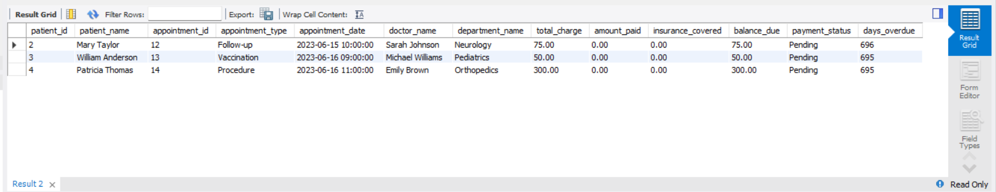

Query 3 (Author: Dhruv Pechetty)

* This query displays the **patient name**, **doctor name**, **doctor's specialization**, and the **appointment notes** for all appointments that have non-empty notes. It also includes the appointment type and status, ordered by the most recent appointment.

Query 4 (Author: Dhruv Pechetty)

* This query retrieves the **emergency contact details** for patients who have **pending payments with outstanding balances**. It includes patient contact info, emergency contact info, count of pending payments, and total balance due, ordered by the highest due amount.

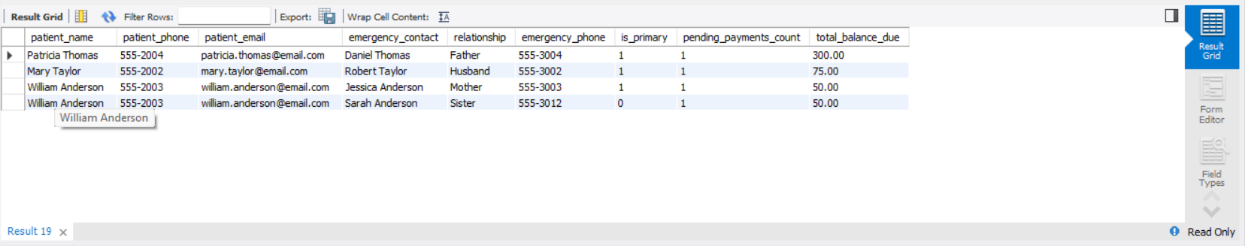

Query 5 (Author: Pranav Vanam)

* This query returns a list of patients who have had appointments with doctors from the **Cardiology department**, excluding cancelled appointments. It shows patient details, the **number of cardiology visits**, and their **most recent cardiology appointment date**, ordered by the latest visit.

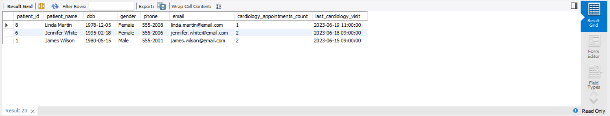

Query 6 (Author: Pranav Vanam)

* This query calculates the **total revenue generated by each doctor** from their appointments by summing up payments and insurance coverage for **completed or partial payments**, excluding cancelled appointments. It also shows each doctor's details and the number of appointments, ordered by highest revenue.

Query 7 (Author: Yuanwei Wu)

* This query shows the **next available doctor** for **today**, based on the current time and their schedule. It lists the doctor’s details and available time slot, ensuring the schedule is valid for the current date.

Query 8 (Author: Yuanwei Wu)

* This query retrieves all doctors who have **more than 10 years of experience**, along with their specialization, department, license number, and contact details, and lists them in **descending order of experience**.

Query 9 (Author: Sai Vikram Karthikeyan)

* This query counts and displays the **total number of non-cancelled appointments**, grouped by **month and year**, and shows the results in **descending order of month** (most recent first).

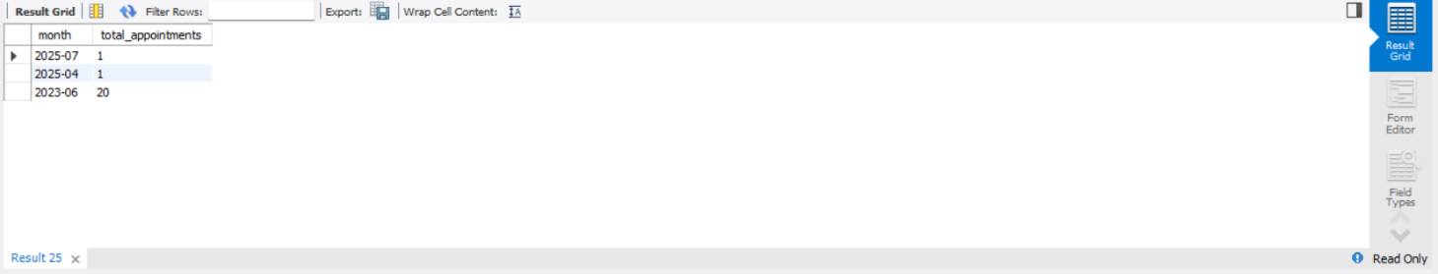

Query 10 (Author: Sai Vikram Karthikeyan)

* This query retrieves the **top 5 patients who have spent the most on payments**. It calculates the total amount spent by each patient, including all their appointments, and orders the result in **descending order of total spent**.

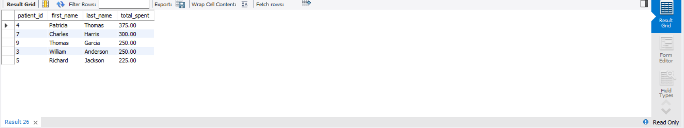

**Stored Procedures**

Stored Procedure 1 - ScheduleAppointment (Author: Udhva Patel)

* The ScheduleAppointment stored procedure schedules an appointment for a patient with a specified doctor by performing several checks. It first verifies the existence of the patient, doctor, and appointment type.
* Then, it checks the doctor's availability based on their schedule and ensures there are no conflicting appointments.
* The procedure also ensures a room is available for the appointment and that there are no conflicts with other scheduled appointments.
* If all checks pass, it schedules the appointment by inserting the relevant data into the Appointment table and returns a success message with the appointment ID.
* If any condition fails, an error is raised with a specific message indicating the issue.

Stored Procedure 2 - GenerateDoctorWeeklySchedule (Author: Udhva Patel)

* The GenerateDoctorWeeklySchedule stored procedure generates a weekly schedule for a specified doctor starting from a given date.
* It first creates a temporary table to hold the schedule details, including each day's date, day name, start and end times, availability status (e.g., "On Leave," "Available," "Not Scheduled"), appointment count, and appointment details (such as patient names and appointment times).
* The procedure then populates the schedule by checking the doctor's scheduled work hours, any time off, and any existing appointments.
* It ensures that appointments are not scheduled during the doctor's time off or outside of the scheduled work hours.
* Finally, the procedure returns the generated schedule for the entire week and cleans up the temporary table after use.

Stored Procedure 3 - GetUpcomingAppointmentsWithDetails (Author: Udhva Patel)

* The GetUpcomingAppointmentsWithDetails stored procedure retrieves a complete view of all upcoming appointments with relevant details.
* It includes information such as the appointment ID, patient and doctor names, doctor's specialization, appointment date and time, appointment type, room number, and the status of the appointment.
* The procedure ensures that only appointments that have not been cancelled and are scheduled in the future are included.
* The results are ordered by the appointment date in ascending order, providing a chronological view of all upcoming appointments.

Stored Procedure 4 - ProcessPayment (Author: Udhva Patel)

* The ProcessPayment stored procedure handles the payment processing for appointments, including both patient payments and insurance claims.
* It first retrieves the current payment details for the given appointment and checks if the payment amount is valid.
* If the payment exceeds the outstanding balance or is invalid, it triggers an error. Depending on whether the payment is made by the patient or through insurance, the procedure updates the relevant fields in the Payments table, adjusting the amount_paid or insurance_covered accordingly.
* It also updates the appointment's status to 'Completed', 'Partial', or 'Pending' based on the payment's impact on the balance.
* Finally, the procedure returns a success message with the new balance after processing the payment.

Stored Procedure 5 - GenerateBillingReport (Author: Udhva Patel)

* The GenerateBillingReport stored procedure generates financial and billing reports for a specified time period and optionally by department.
* It calculates the total number of appointments, the total billed amount, total payments received, total insurance coverage, outstanding balances, and the average bill amount for each department.
* The report is filtered by the given start and end dates and, if provided, by the department ID. The results are grouped by department name and ordered by the total billed amount in descending order.
* This procedure is useful for tracking the financial performance of departments within a specific time frame.

**Functions**

Function 1 - CalculatePatientAge (Author: Udhva Patel)

* The CalculatePatientAge function is used to determine a patient's current age based on their date of birth stored in the Patients table.
* It takes the patient’s ID as input, retrieves their date of birth, and calculates the age in years using the TIMESTAMPDIFF() function with the current date.
* The function then returns the age as an integer.

Why we choose this function

* This function is useful because it centralizes and simplifies the age calculation process, making it reusable and consistent across the system.
* It improves code readability and helps in scenarios like age-based medical decisions, reporting, and patient categorization without repeating the same logic in multiple queries.

Function 2 - FormatPhoneNumber (Author: Udhva Patel)

* The FormatPhoneNumber function is designed to format a raw phone number string into a more readable and standardized format.
* It takes a 10-digit phone number as input (stored as a string) and returns it in the format (XXX) XXX-XXXX, which is commonly used in many countries like the United States.
* It does this using the SUBSTRING() function to extract parts of the number and the CONCAT() function to piece them together with formatting characters.

Why we choose this function

* This function is useful because it ensures consistency in how phone numbers are displayed across the system, enhancing readability and professionalism in reports, patient profiles, or appointment confirmations.
* It saves time by avoiding repetitive formatting logic in different parts of the application.

Function 3 - GetTotalPaymentsForAppointment (Author: Yuanwei Wu)

* The GetTotalPaymentsForAppointment function calculates the total billed amount for a specific appointment.
* It takes an appointment ID (appId) as input and returns the sum of all amount entries from the Payments table associated with that appointment.
* If no payments are found for the given appointment, it returns 0.00 using the IFNULL() function to avoid returning a null value.

Why we choose this function

* This function is useful for quickly retrieving the total billing amount linked to an appointment, which can be used in financial reports, patient billing summaries, or dashboards.
* It simplifies code reuse and maintains consistency in payment calculations across the system.

Function 4 - GetPatientLastVisit (Author: Yuanwei Wu)

* The GetPatientLastVisit function returns the most recent completed appointment date and time for a given patient.
* It takes a patient ID as input and searches the Appointments table for records where the status is 'Completed'.
* It then uses the MAX() function to find the latest appointment date for that patient and returns it.

Why we choose this function

* This function is useful for tracking patient history, enabling the system to quickly display the last time a patient visited the hospital or clinic.
* It can be used in dashboards, patient profiles, or during new appointment bookings to provide context on a patient’s previous interactions.

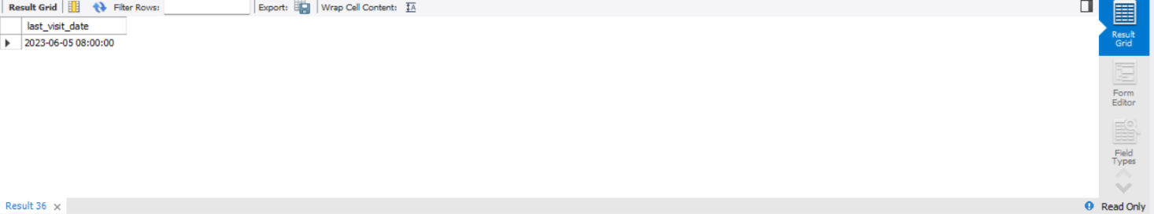

Function 5 - GetAppointmentCountForDoctorOnDate (Author: Yuanwei Wu)

* The GetAppointmentCountForDoctorOnDate function returns the total number of scheduled appointments for a specific doctor on a given date.
* It takes two parameters: the doctorId and the targetDate.
* It filters the Appointments table by doctor_id, matches the appointment_date with the provided date, and only counts those with the status 'Scheduled'.

Why we choose this function

* This function is particularly useful for hospital management systems to check a doctor’s workload on a specific day.
* It helps in balancing appointments, avoiding overbooking, and planning resources like room availability or support staff accordingly.

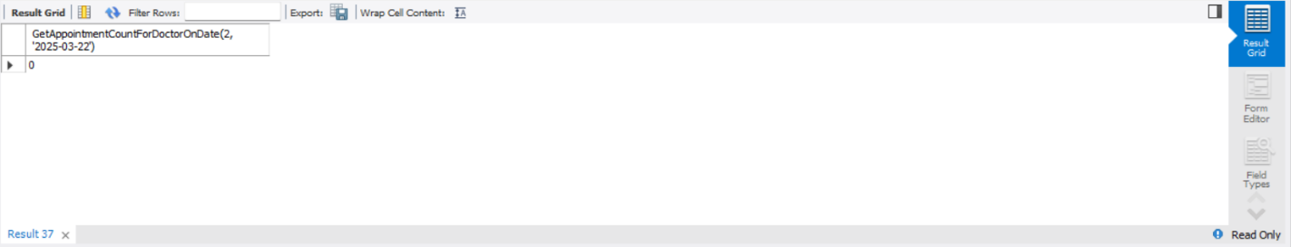

**Triggers**

Trigger 1 - trg_check_room_capacity (Author: Sai Vikram Karthikeyan)

* The trigger trg_check_room_capacity ensures that a room is not overbooked by validating its capacity before a new appointment is inserted into the Appointments table.
* It checks for overlapping appointments in the same room and compares the count with the room's defined capacity.
* If the number of concurrent appointments equals or exceeds the room's capacity, the trigger raises an error and prevents the insertion.
* This helps maintain data integrity, avoids overbooking issues, and automates room capacity enforcement directly at the database level, reducing the need for manual checks in the application logic.



Trigger 2 - trg_prevent_duplicate_allergy (Author: Sai Vikram Karthikeyan)

* This trigger trg_prevent_duplicate_allergy is designed to prevent the insertion of duplicate allergy records for the same patient in the patientallergies table.
* It activates before an insert operation and checks if there already exists a record with the same patient_id and allergy_name.
* If such a record is found, the trigger raises an error using SIGNAL SQLSTATE '45000' with a custom message: "Duplicate allergy entry for this patient is not allowed."
* This ensures data integrity by enforcing that no patient has the same allergy recorded more than once.



Trigger 3 - auto_assign_doctor (Author: Sai Vikram Karthikeyan)

* The auto_assign_doctor trigger is designed to automatically assign a doctor and room to an appointment before it is inserted into the Appointments table.
* If no doctor is provided in the doctor_id field, it first calculates the duration of the appointment based on its type and assigns an end_time if it's not provided.
* It then identifies the appropriate department and creates a specialization pattern for matching doctors based on the appointment type.
* The trigger searches for available doctors who are not already scheduled at the appointment time and who are not on time off.
* It also considers the doctor's schedule to ensure they are available.
* Additionally, the trigger looks for an available room in the corresponding department and assigns it if available.
* If a suitable doctor and room are found, they are assigned to the new appointment.
* This process helps streamline appointment scheduling by automatically assigning the necessary resources without requiring manual intervention.



Trigger 4 - prevent_double_booking (Author: Pranav Vanam)

* The prevent_double_booking trigger ensures that a doctor cannot be double-booked for overlapping appointments.
* Before a new appointment is inserted into the database, it checks whether there is already an existing appointment for the same doctor that conflicts with the proposed time.
* The trigger compares the appointment times and raises an error if it detects a scheduling conflict, preventing the insertion of the new appointment.
* This ensures that the system does not allow multiple appointments for the same doctor at the same time, maintaining scheduling accuracy and preventing operational issues.



Trigger 5 - prevent_past_appointment (Author: Pranav Vanam)

* The prevent_past_appointment trigger prevents users from scheduling appointments in the past, which could lead to confusion or inaccurate records.
* When an appointment is being added, the trigger compares the proposed appointment date with the current date and time NOW().
* If the proposed appointment date is in the past, it raises an error, ensuring that appointments are only scheduled for future times.
* This helps maintain the integrity of the system by ensuring that all appointments are valid and relevant to the current timeframe.
* Together, these triggers help enforce logical consistency in the appointment scheduling process.



**Data Security**

Ensuring the **security and confidentiality** of patient and appointment data is a critical component of the **HealthConnect** Appointment Management System. The system handles sensitive information such as personal details, medical appointments, and doctor availability, which must be protected from unauthorized access, loss, or misuse.

### **5.1. Key Data Security Measures**

#### **1. User Authentication and Role-Based Access**

* Implement secure **login systems** for patients, doctors, and administrators.
* Use **role-based access control (RBAC)** to limit data visibility:
  + **Patients**: Can view and manage their own appointments only.
  + **Doctors**: Can access only their appointment schedules.
  + **Admins**: Have full access to all data and user management.

#### **2. Password Encryption**

* Store passwords in the **Admin** and **User** tables using strong hashing algorithms (e.g., **bcrypt**, **SHA-256**) to prevent exposure of plain-text credentials.

sql

CopyEdit

-- Example (plaintext for demo; always hash in real use):

INSERT INTO Admin (Username, Password) VALUES ('admin1', SHA2('securePassword', 256));

#### **3. SQL Injection Prevention**

* Use **prepared statements** and **parameterized queries** in all application-level database interactions to prevent SQL injection attacks.

#### **4. Data Validation and Sanitization**

* Validate all user inputs at both frontend and backend to avoid malicious entries.
* Restrict special characters in fields like names, emails, and phone numbers.

#### **5. Access Logs and Audit Trails**

* Maintain logs of all system access and modifications (who logged in, what changes were made).
* Useful for monitoring, detecting breaches, and forensic analysis.

#### **6. Regular Backups**

* Schedule **daily automatic backups** of the database to ensure data recovery in case of hardware failure or data corruption.
* Store backups in **encrypted formats** on secure cloud or local servers.

#### **7. Data Encryption (at Rest and in Transit)**

* Apply **data-at-rest encryption** using database-level encryption features (e.g., MySQL TDE).
* Ensure **data-in-transit encryption** using HTTPS (SSL/TLS) when connected to a frontend.

#### **8. Session Management**

* Implement secure session handling (e.g., timeouts, session tokens) to prevent unauthorized access due to open or hijacked sessions.

## **Implementation of AI and AI Assistant in HealthConnect**

Artificial Intelligence (AI) has the potential to significantly enhance the **HealthConnect** Appointment Management System by automating tasks, improving decision-making, and offering intelligent user support. Integration of AI can lead to a more efficient, responsive, and user-friendly healthcare experience.

### **6.1. AI Use Cases in HealthConnect**

#### **1. AI Chatbot / Virtual Assistant**

* An integrated AI chatbot can:
  + Assist patients in booking or canceling appointments via natural language conversation.
  + Answer common queries about doctor availability, timings, or clinic policies.
  + Offer multilingual support to cater to diverse patient demographics.

**Technologies:**

* NLP models (e.g., Dialogflow, Rasa, GPT APIs)
* Integration with the backend SQL database to retrieve real-time information.

**Sample Flow:**

User: "I want to book an appointment with a cardiologist."

Bot: "Dr. Mehta (Cardiologist) is available at 4 PM tomorrow. Should I confirm?"

User: "Yes."

Bot: "Your appointment has been scheduled."

#### **2. Intelligent Appointment Recommendations**

* AI can analyze:
  + A patient’s history, preferred time slots, and doctor availability.
  + Suggest optimal appointment times.
  + Detect peak hours and reduce wait times using machine learning models.

**Example Algorithm:**

* Decision tree or logistic regression models to predict optimal slot based on:
  + Day of week
  + Doctor load
  + Cancellation probability

#### **3. Predictive Analytics for No-Show and Cancellations**

* ML models can predict which appointments are likely to be missed using historical data and behavioral patterns (e.g., patient delay history, weather conditions, reminder response).
* This can help:
  + Send automated reminders
  + Optimize scheduling by overbooking in safe margins

#### **4. Sentiment Analysis and Feedback Classification**

* Analyze feedback from patients to assess service quality.
* Automatically categorize feedback into:
  + Positive, Negative, or Neutral
  + Complaint, Suggestion, Praise

**Example Model:**

* Sentiment classification using pretrained BERT or SVM with TF-IDF features.

#### **5. Doctor Performance & Load Analytics**

* AI models can track:
  + Appointment volume
  + Average consultation time
  + Patient satisfaction scores
* Provide dashboards for admin decision-making.

### **6.2. Technical Architecture (Conceptual)**

User ➝ Frontend UI or Chatbot ➝ AI Engine (NLP + ML) ➝ SQL Database ➝ HealthConnect Backend

* **Frontend**: Web/app interface or chatbot UI
* **AI Layer**: Python-based ML/NLP services (Flask/FastAPI + scikit-learn/Transformers)
* **Database**: SQL backend for storing appointments, user data, feedback

### **Benefits of AI Integration**

|  |  |
| --- | --- |
| Benefit | Description |
| Automation | Reduces Manual Intervention for bookings and queries. |
| Personalization | Suggests doctors and time slots based on history. |
| Efficiency | Improve resource utilization and reduce wait times. |
| Decision Support | Provides insights to doctors and admins |
| Patient Satisfaction | Better response time and proactive service |

## **Conclusion**

The **HealthConnect Appointment Management System** is a comprehensive, SQL-based solution designed to streamline the process of scheduling and managing medical appointments in clinics and hospitals. By leveraging the power of **relational database design**, the system ensures data consistency, security, and accessibility for all stakeholders—patients, doctors, and administrators.

Through careful implementation of normalized database structures and secure access controls, HealthConnect addresses key operational challenges in healthcare such as inefficient scheduling, missed appointments, and data mismanagement. The integration of **AI and intelligent assistants** further enhances the platform by providing smart appointment suggestions, virtual assistant capabilities, and predictive analytics, leading to improved patient experience and resource utilization.

The project demonstrates not only the technical application of database management principles but also how modern technologies like **AI and NLP** can be seamlessly integrated into traditional systems to deliver **smart, user-friendly, and scalable solutions** in real-world domains.Looking ahead, HealthConnect has the potential to be expanded into a full-fledged **hospital management system** with features like medical history tracking, billing, diagnostics, and e-prescriptions—making it a solid foundation for digital healthcare transformation.